|  |  |
| --- | --- |
|  | **2013** |
|  | HH Electronic Solutions  Hai Nguyen |

|  |
| --- |
| **ENginerING LOGBOOK]** |
| [Type the abstract of the document here. The abstract is typically a short summary of the contents of the document. Type the abstract of the document here. The abstract is typically a short summary of the contents of the document.] |

|  |  |  |  |
| --- | --- | --- | --- |
| Task name | How to connect NRF24L01+ 2.4GHz with Arduino | | |
| Owner: Hoang Hai | | Duration: 1h30 | Sunday, August 18, 2013 |

Link: <http://arduino-info.wikispaces.com/Nrf24L01-2.4GHz-HowTo>

|  |  |  |  |  |
| --- | --- | --- | --- | --- |
| Signal | RF Module | COLOR | Arduino pin for RF24 Library | Arduino pin for Mirf Library |
| GND | 1 | Brown | GND | GND |
| VCC | 2 | Red | 3.3V | 3.3V |
| CE | 3 | Orange | 9 | 8 |
| CSN | 4 | Yellow | 10 | 7 |
| SCK | 5 | Green | 13 | 13 |
| MOSI | 6 | Blue | 11 | 11 |
| MISO | 7 | Violet | 12 | 12 |
| IRQ | 8 | Gray | 2 * |  |

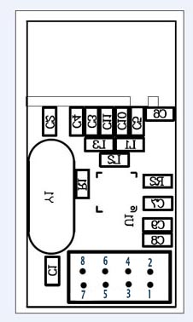

We have to RF24 library:

1.

Link: <http://maniacbug.github.io/RF24Network/index.html>

Copy code to owner folder

<http://arduino-info.wikispaces.com/nRF24L01-RF24-Examples>

2.

Link <http://playground.arduino.cc/InterfacingWithHardware/Nrf24L01>

Copy code to owner folder

|  |  |  |  |
| --- | --- | --- | --- |
| Task name | Design of Relay + switch node | | |
| Owner: Hoang Hai | | Duration: | Date: Monday, August 19, 2013 |

Design requirement:

1. Switch and relay controls the light

2. switch can control the light regarding the state of relay and vice versa.

3. MCU can know the state of light

4. Can combine with occupancy sensor

5.

Jeenode design

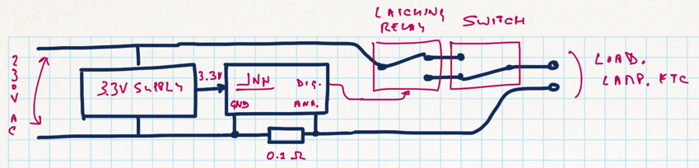

|  |  |  |  |
| --- | --- | --- | --- |
| Task name | Test the Pro Mini Arduino | | |
| Owner: Hoang Hai | | Duration: | Date: Wednesday, September 04, 2013 |

1. Pro Mini Arduino

<http://arduino.cc/en/Main/ArduinoBoardProMini>

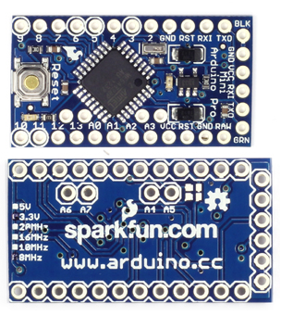

Buy in alibaba express: <http://www.aliexpress.com/item/2pcs-lot-New-Pro-Mini-atmega328-5V-16M-Replace-ATmega128-Arduino-Compatible-Nano/975304122.html>

Test new

2. Connect Pro Mini with Arduino board.

Step 1: Connect jumper

|  |  |
| --- | --- |
| duemilanove | Pro mini |
| GND | GND |
| TX1 | TX0 |
| RX0 | RX1 |
| 5V | VCC |
| RESET | DTR |

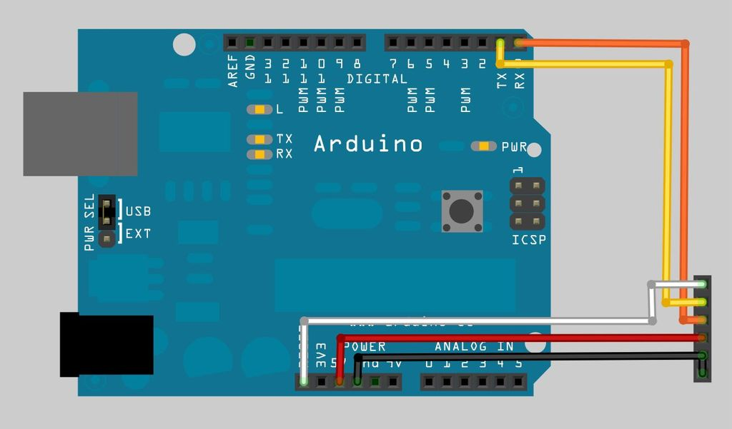

Step 2.

Plug the arduino into the USB lead as normal

Step 3.

In the Arduino IDE, Select - Tools->Board->'ArduinoPro or Pro Mini w/atmega328'

(Or whatever version of the board you are uploadingto)

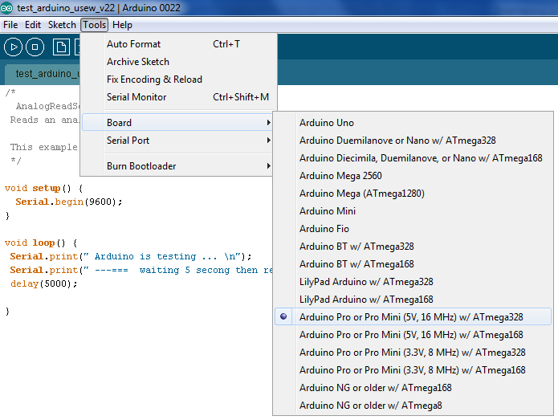

Step 4.

Load/Type your sketch into the IDE.

|  |
| --- |
| /*  Blink  Turns on an LED on for one second, then off for one second, repeatedly.  Send the serial signal through FDTI  This example code is in the public domain.  */  void setup() {  // initialize the digital pin as an output.  // Pin 17 has an LED connected on most Arduino boards:  pinMode(13, OUTPUT);  Serial.begin(9600);  }  void loop() {  digitalWrite(13, HIGH); // set the LED on  delay(1000); // wait for a second  digitalWrite(13, LOW); // set the LED off  delay(1000); // wait for a second  Serial.print(" Arduino is testing ... \n");  Serial.print(" ---=== waiting 5 secong then resend this message ===--- \n");  delay(1000);  } |

Step 5.

Click the Upload Icon or Click File->Upload

Step 6.

Look on the led and open the serial monitor

If there are any error messages - Double check the wiring, The most common cause of error is

connecting the Rx and Tx lines back to front.

|  |  |  |  |
| --- | --- | --- | --- |
| Task name | Connect guruplug with PC | | |
| Owner: Hoang Hai | | Duration: 1 hour | Date: |

Step 1:

Connect USB drive to guru plug.

Step 2: Connect wifi to guruplug

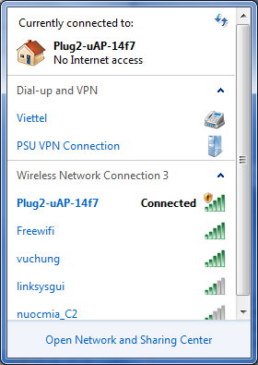

Step 3: set up IP address:

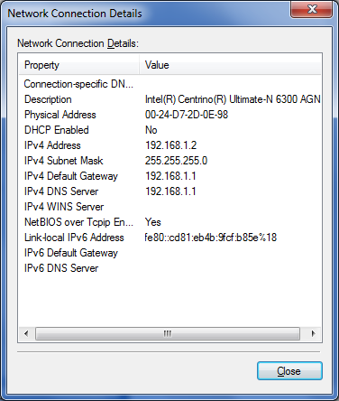

Step 4: Connect to web:

<http://192.168.1.1/secret.html>

step 5: connect by puty:

192.168.1.1:22

|  |  |  |  |
| --- | --- | --- | --- |
| Task name |  | | |
| Owner: Hoang Hai | | Duration: | Date: |